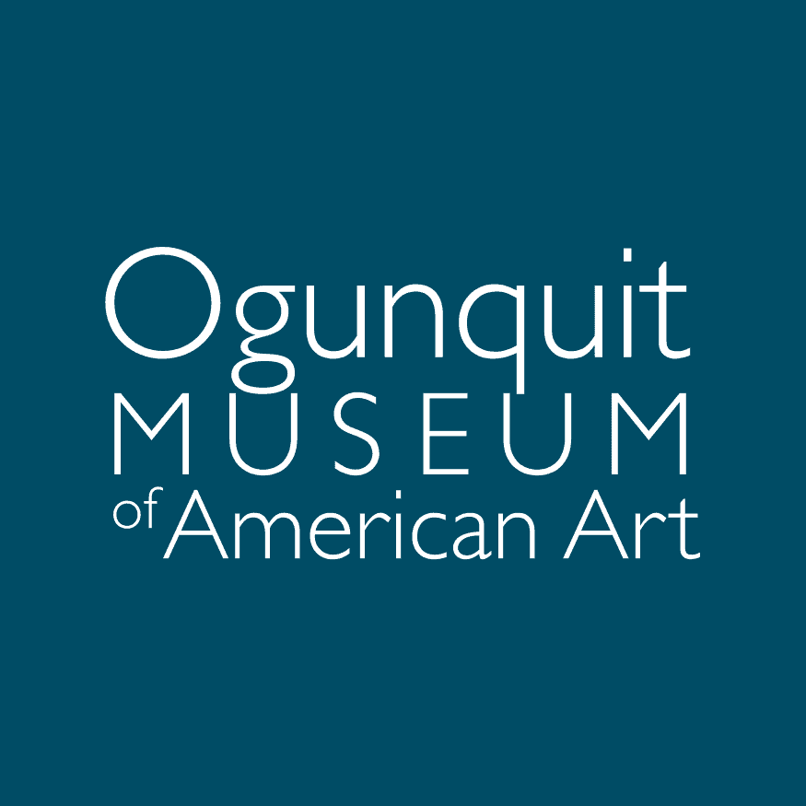

**Finance Manger**

The Ogunquit Museum of American Art (OMAA) seeks an experienced finance professional to work with the Executive Director and Treasurer in a part-time oversight role, ensuring the highest standards of accuracy, accountability and communication.

Duties: 5-8 hours weekly.

* Check that QuickBooks is accurate monthly,
* Review of internal documents prior to the accounting firm,
* Work with the Treasurer to check financial statements for accuracy,
* Maintain oversight and recommendations for software that internally track deposits, invoices, credit card payments, checks, and other miscellaneous monetary transactions,
* Coordinate with staff to prepare the overall budget for the museum in October and November, ready for board approval in December.

Other:

* Provide other financial assistance when requested,
* Help to ensure all information is uploaded and processed accurately with the correct budget code.

Technical Skills

* Bachelor’s degree and at least 1–2 years of professional experience required.
* Proficiency in QuickBooks and Microsoft Office Suite (Word, Excel, PowerPoint). Familiarity with donor management software (e.g., Salesforce) preferred.
* Aptitude for mastering office technology, including troubleshooting when needed.

This job description outlines general expectations and may evolve over time. The Ogunquit Museum of American Art is an Equal Opportunity Employer.

**About the Ogunquit Museum of American Art**

Opened in 1953, OMAA was founded by Lost Generation artist Henry Strater. Closely tied to one of the earliest art communities of the American modernist art movement, OMAA today houses a permanent collection of paintings, sculpture, drawings, prints, and photographs from the late 1800s to the present. The museum showcases American art by mounting modern and contemporary exhibition programs from April through November. OMAA’s seaside landscape—a three-acre sculpture park containing multiple small gardens—complements its exhibitions and overlooks Narrow Cove and the Atlantic Ocean.

More information at [www.ogunquitmuseum.org](http://www.ogunquitmuseum.org/).

**Salary commensurate with experience. Please email a cover letter, resume, and the names of three references to** [**hr@ogunquitmuseum.org**](mailto:hr@ogunquitmuseum.org)**. Interviews begin immediately and will continue until the position is closed.**