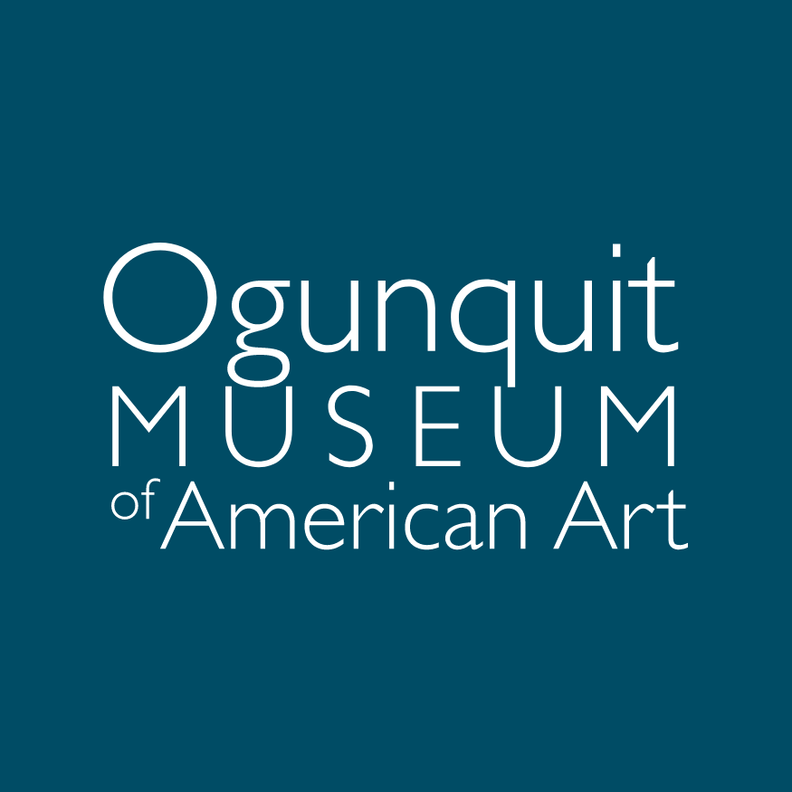
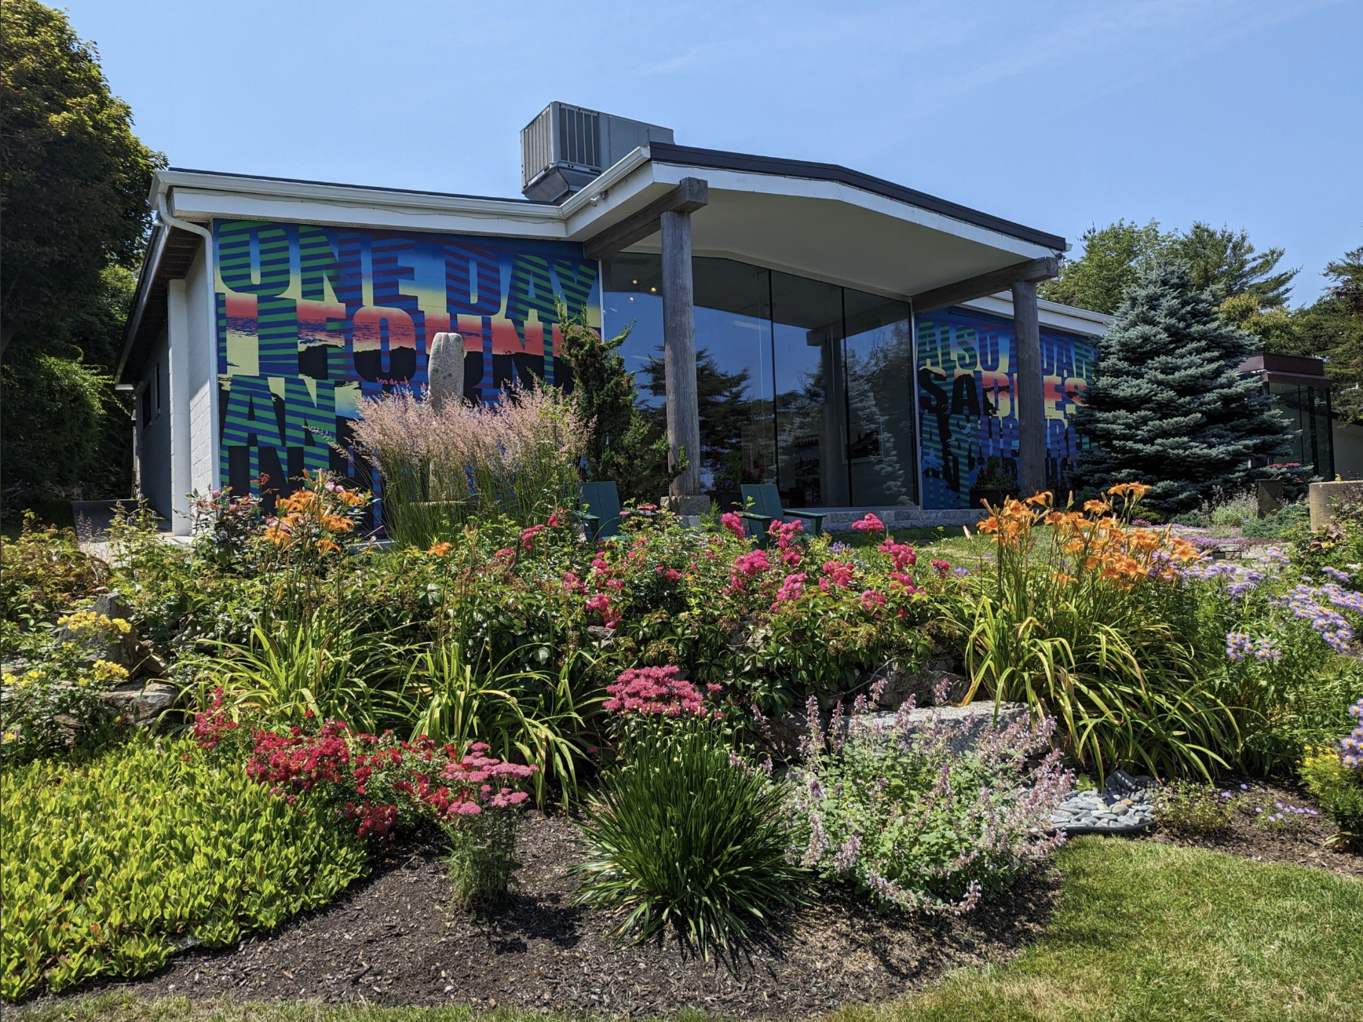

Educator & Student Pre-Visit Guide
543 Shore Road | Ogunquit, ME 03907 | 207.646.4909 | info@ogunquitmuseum.org

Thank you for considering OMAA for your next field trip! We understand that there is a lot of information to keep track of, so we have designed this packet to provide a brief overview of the museum's history, guidelines and rules to share with your students, and resources to support your visit. If you have questions or feedback at any point, please do not hesitate to reach out!

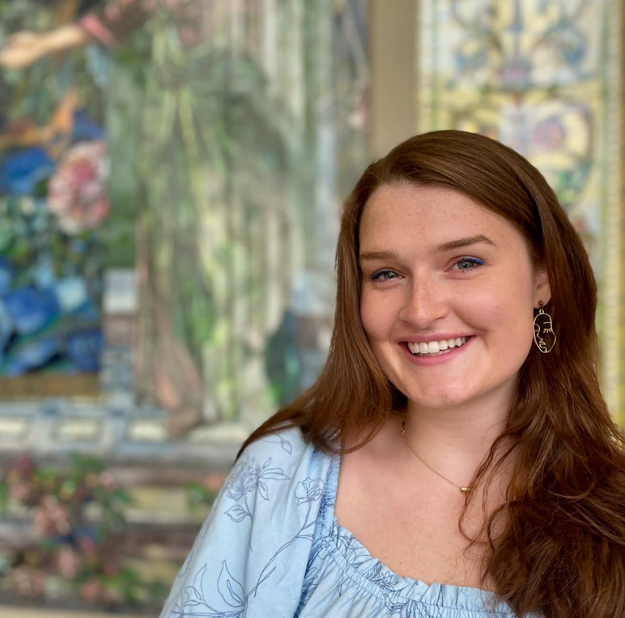
Sophie Cordery
Education and Community Outreach Fellow
scordery@ogunquitmuseum.org

A Brief History of OMAA

The Ogunquit Museum of American Art (OMAA) was founded by Lost Generation artist Henry Strater and opened in 1953. Closely connected to two of America’s earliest art communities that directly contributed to the roots of American modernism, OMAA today houses a permanent collection of important paintings, sculpture, drawings, prints, and photographs from the late 1800s to the present. A short walk from Perkins Cove, the museum and its three acres of sculpture gardens overlook Narrow Cove and the Atlantic Ocean.

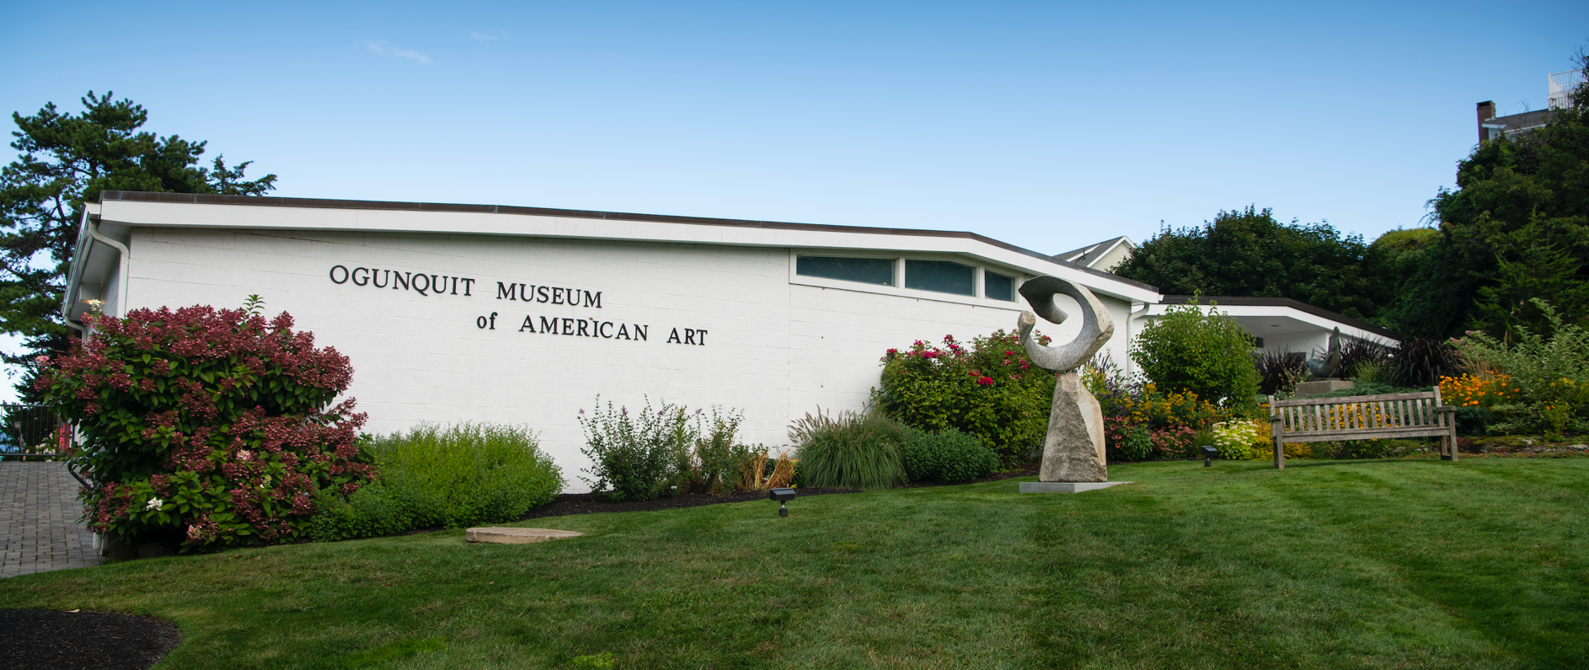

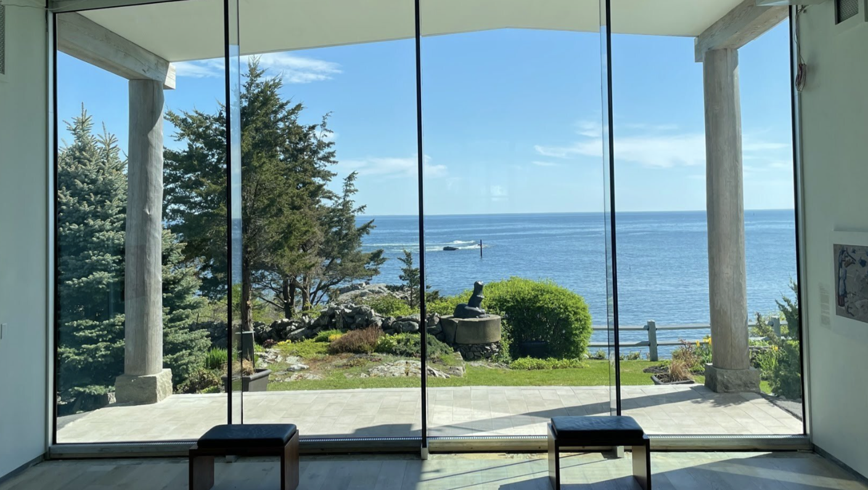
Schedule Your Visit

Scheduling Your Visit:
- Contact Sophie Cordery at scordery@ogunquitmuseum.org.
- Confirm chaperones: we recommend one adult for every 7-10 students due to the museum's small space.
- Onsite visits are available daily from 10:00 a.m. to 5:00 p.m., April to November. For off-season, contact Sophie Cordery for in-classroom visits.
- For groups over 40 students, special arrangements can be made for early visits before the museum opens.
- (Optional) Schedule a classroom visit with a museum representative to lead an activity and discuss museum navigation, tailored to your current curriculum.

Preparing for Your Visit:
- Food, drinks, and art making materials, including pens and pencils, are not allowed inside the Museum. Please remind students to leave these on the bus and review the guidelines with them. Exceptions can be made at the discretion of Museum staff.
- Ensure guardians complete the photo-release form (included in this packet), which will be collected at the start of the visit.
- Weather permitting, enjoy a picnic on the grounds!
- Please provide the recommended number of chaperones: 2 per 10 students for grades K-6, and 1 per 10 students for grades 7-12.
- Parking for large buses is limited. Please coordinate with a museum representative ahead of your visit.
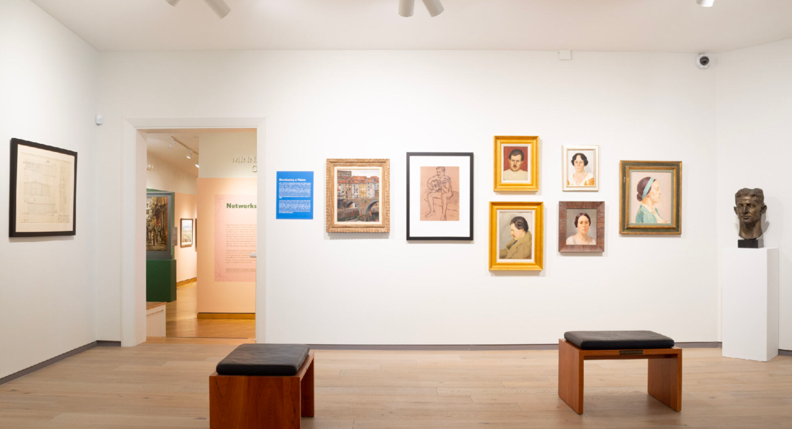
Itinerary Example:
School visits typically last for one to two hours. Here is a sample schedule which can be adjusted to your specifics:

10:00 AM....Bus arrives
10:15 AM... Students assemble at the front of the museum for a brief introduction, history of the museum, and overview of the day.
10:15-20 AM... Students split into groups depending on size. For example:
- Groups of 20...two groups of ten (1-2 chaperones per group or 4 total)
- Groups of 30...three groups of ten (1-2 chaperones per group or 4 total)
- Groups of 40...four groups of 10 (1-2 chaperones per group or 6 total)
10:30-11:15 AM... Student groups rotate through activity stations. This can be adjusted to your preference. For example:
- Two groups....1) tour of the museum and 2) art activity (switch after twenty minutes)
- Three groups...1) tour of the museum, 2) art activity and 3) scavenger hunt/writing activity (switch after 15 minutes)
- Four groups...2) tour of the museum, 2) art activity 3) scavenger hunt/writing activity (switch after 15 minutes)
11:15-30 AM... Closing remarks and recap of the day led by museum staff.
11:30-12:00 PM... Students and teachers meet in the grounds to discuss their own curriculum, final activity, or picnic lunch on the grass.
12:00-12:10 PM... Buses to depart.

Activity Breakdown
These activities are subject to your specifications and are provided as guidelines. Please let Sophie Cordery know if you would like to adjust or replace any of these to fit your curriculum:
Activity One: Tour of the Museum
Our galleries are always changing with exciting new exhibitions! This portion of the tour can focus on a particular exhibition, a complete overview of multiple exhibitions, the history of the museum, or a deep dive into one artwork that connects with your curriculum plan.

Activity Two: Art Activity
Ranging from drawing, painting, or collage activities, this portion of the day is meant to focus on art making to complement the history portion of the tour. Students may choose to spread out across the grounds to complete live drawing exercises or focus on completing a larger group project. This can also be time for a project you are working on together in the classroom from film to photography. Please plan on bringing a few supplies to support this type of activity.
Activity Three: Scavenger Hunt or Writing Activity
Movement and creative writing are important components to leveraging creating thinking. For the scavenger hunt, students will break into smaller groups to find artwork and sculpture throughout the galleries and grounds. Along the way, they will be prompted to answer a series of questions and close-looking exercises. Alternatively, students can engage in an ekphrastic writing activity in which students choose one work of art to respond to through poetry or creative writing.

Student Guidelines to Museum Etiquette
Visiting a museum is super fun, and we at OMAA can’t wait to welcome you! The museum staff are here to protect the art so people can enjoy it for years. You can help too! Here are some important rules to follow:

Before you get started, let’s STOP and ask about our T’s

Step Back!
Take a moment to look at the room and where objects or paintings are on the walls. A good rule: you should never be close enough to extend your arm and touch the painting.
Tread carefully
You will want to look at the artwork from a few angles, but you must always be aware of your body in relation to the painting.
Open your eyes and ears
There may be text to read or a guide informing you about the artwork.
Participate
This can be done by looking at the artwork, listening to the guide, or asking a museum staff member a question. Before you leave, find your favorite painting and ask yourself why it was your favorite!
Looking at a painting or object and don’t know where to start? Think about your T’s!
Time...can you tell the time of day in the painting? What might give you clues? Maybe a clock on the wall, an open window, shadows from people or objects.
Tone...this is an art term that means the lightness or darkness of the overall painting. Some paintings are light and bright, other paintings are dark and gloomy. What might the artist be trying to communicate with you through light and dark?
Texture...does the painting look smooth or rough? Remember, no touching! Practice looking at the painting from different angles to see the surface texture. This may tell you the medium or what the artist used to paint the picture.
Text...you can learn lots of information from the wall text panel to the side of the artwork. Go to a few wall texts and see what details are always shared (hint: the title of the painting is always given to you!)

PHOTO RELEASE
During your visit, staff may take pictures of your group on a tour for use in our advertising, collateral or marketing materials. We ask that you provide permission to photograph your students and to use them in our materials. If you are willing to let us do so, please read and sign:
I give my permission for the Ogunquit Museum of American Art (OMAA) to photograph my students for use in marketing.
Date:
Signature:
Please print name:
School Name:
Grade Level:

If you have any students who may not be photographed, please list them below. We will work with you to keep them out of any photos taken.

THANK YOU!

Post-Visit Survey
We are committed to improving our education programming and would love to hear your feedback! After your visit, we will send you a short survey via email. The survey will include the following questions:
1. Overall Experience
How would you rate your overall experience at the museum?
☐ Excellent
☐ Good
☐ Average
☐ Poor
2. Educational Value
How would you rate the educational value of the museum visit for your students?
☐ Excellent
☐ Good
☐ Average
☐ Poor
3. Museum Tour & Exhibits
Were the exhibits and tour content engaging and relevant to your curriculum?
☐ Yes
☐ Somewhat
☐ No

4. Museum Staff
How would you rate the interaction with the museum staff and guides?
☐ Excellent
☐ Good
☐ Average
☐ Poor
5. Pre-Visit Materials
Did you find the pre-visit materials (if provided) helpful in preparing your class for the visit?
☐ Yes
☐ Somewhat
☐ No
☐ Did not use
6. Logistics and Organization
How would you rate the organization of the visit (scheduling, check-in, timing)?
☐ Excellent
☐ Good
☐ Average
☐ Poor
7. Student Engagement
Did your students find the visit engaging and enjoyable?
☐ Yes
☐ Somewhat
☐ No
8. Suggestions for Improvement
Do you have any suggestions for improving future field trips to the museum?
Your response:

9. Additional Comments
Any additional feedback or comments?
Your response:

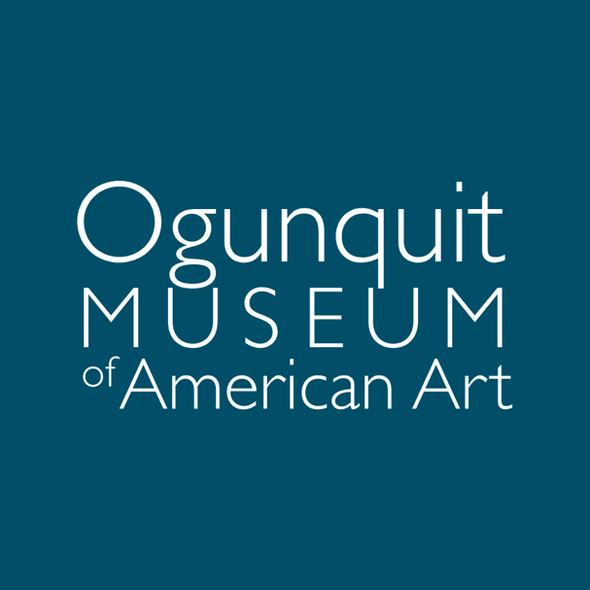
We look forward to welcoming you to the Museum soon!

