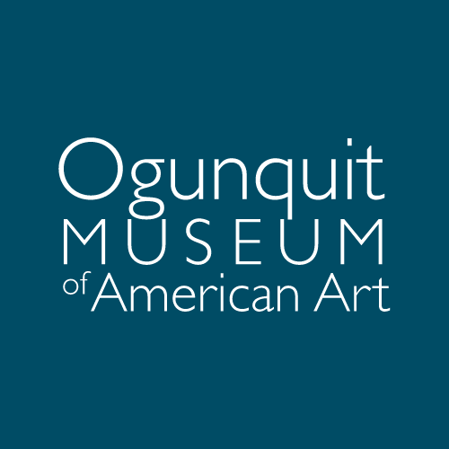

ADVANCEMENT COORDINATOR
The Ogunquit Museum of American Art (OMAA) seeks a highly motivated, detail-oriented professional to join our Advancement team. Primary responsibilities include maintaining donor records, managing gift processing and acknowledgments, supporting appeals and events, and assisting with all museum fundraising initiatives. The ideal candidate will bring strong organizational skills, database proficiency, and a passion for modern and contemporary art. This full-time position reports to the Director of Advancement and works closely with a collaborative and dedicated team.

Key Responsibilities
- Manage donor database operations, ensuring accurate and timely entry of donor details and activities.
- Provide administrative support to the Director of Advancement, including scheduling, preparing reports and data visualizations, and tracking departmental progress.
- Assist with donor communications, including acknowledgment letters, thank-you notes, and general stewardship efforts.
- Support the creation of proposals, fundraising materials, event calendars, and related collateral.
- Plan and execute fundraising and volunteer events such as donor cultivation receptions, galas, and community outreach activities.
- Assist with direct mail campaigns, online fundraising efforts, membership drives and renewals, and annual appeals.
- Research and cultivate prospective donors, including foundations and grants, maintaining grant materials and generating follow-up reports.
- Collaborate across departments to support institutional needs.
- Perform other duties as assigned.

Qualifications / Personal Qualities
- Excellent written and verbal communication skills.
- Superior organizational abilities with exceptional attention to detail and accuracy.
- A positive, collaborative attitude with an ability to build relationships with donors and community partners.
- Demonstrated discretion, confidentiality, and sound judgment when handling sensitive information.
- Flexibility to work occasional evenings or weekends for events.
- Passion for the arts, with a particular enthusiasm for modern and contemporary art.
- Commitment to fostering diversity and inclusion within the workplace and community.

Technical Skills
- Bachelor’s degree and 1–2 years of professional experience required.
- Proficiency in Microsoft Office Suite (Word, Excel, PowerPoint). Familiarity with donor management software (e.g., Salesforce) preferred.
- Experience with graphic design or marketing a plus.
- Aptitude for mastering office technology, including troubleshooting when needed.
- Prior experience in development/advancement is advantageous but not required.

This job description outlines general expectations and may evolve over time.
The Ogunquit Museum of American Art is an Equal Opportunity Employer.

About the Ogunquit Museum of American Art
Opened in 1953, OMAA was founded by Lost Generation artist Henry Strater. Closely tied to one of the earliest art communities of the American modernist art movement, OMAA today houses a permanent collection of paintings, sculpture, drawings, prints, and photographs from the late 1800s to the present. The museum showcases American art by mounting modern and contemporary exhibition programs from April through November. OMAA’s seaside landscape—a three-acre sculpture park containing multiple small gardens—complements its exhibitions and overlooks Narrow Cove and the Atlantic Ocean.
More information at www.ogunquitmuseum.org.

Salary commensurate with experience. Benefits include health insurance, vacation, and SIMPLE IRA. Please email a cover letter, resume, and the names of three references to hr@ogunquitmuseum.org. Interviews begin immediately and will continue until the position is closed.

