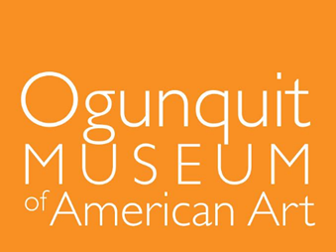

**Education and Community Outreach Fellow**

The Education and Community Outreach Fellowship offers an early-career individual an exciting opportunity to define, develop, and execute educational and outreach initiatives that further the museum’s mission to become more accessible to broader audiences and highlight the richness and diversity of American art and culture. Duties include designing, providing, and overseeing educational programing that will engage visitors (children, teens, and adults) in the galleries, in schools, and online. The candidate will work closely with the Curatorial Department to develop interpretative strategies for the museum's collection and special exhibitions. Working collaboratively with colleagues in Institutional Advancement, the candidate will expand the museum’s presence beyond its walls and into surrounding communities, fostering innovative strategies for outreach and engagement. Over three years, this position will not only allow the museum to advance its educational goals and capacity, it will also provide an emergent professional in museum education, or a closely related field, an important foundation for their future career. The Fellow will gain skills in community outreach & engagement, public speaking, teaching & learning, object interpretation, and museum management.

The Education and Community Outreach Fellow will report to the Curator of Modern and Contemporary Art who oversees scholarly standards at OMAA. The Fellow will play a vibrant role in weekly staff meetings, at volunteer and docent events, and will work closely with the staff to execute programming.

B.A. or B.S. with graduate degree preferred, or equivalent experience.

This job description is intended to be general and will evolve over time.

The Ogunquit Museum of American Art is an Equal Opportunity Employer.

**About the Ogunquit Museum of American Art**

Opened in 1953, OMAA was founded by Lost Generation artist Henry Strater. Closely tied to one of the earliest art colonies of the American modernist art movement, OMAA today houses a permanent collection of paintings, sculpture, drawings, prints, and photographs from the late 1800s to the present. The museum showcases American art by mounting seasonal modern and contemporary exhibition programs from May through October. OMAA’s seaside landscape—a three-acre sculpture park containing 18 small gardens—complements its exhibitions and overlooks Narrow Cove and the Atlantic Ocean. The museum is open April through November. More information at [www.ogunquitmuseum.org](http://www.ogunquitmuseum.org/).

***Salary commensurate with experience. Please email a cover letter and resume to hr@ogunquitmuseum.org by December 15, 2023. Interviews begin immediately and will continue until the position is closed. The position begins January 1st.***